* **Activity 1:**

### Using Aggregate Functions in SELECT Statement

**Display the average, highest, lowest, and sum of ticket prices for all flights**

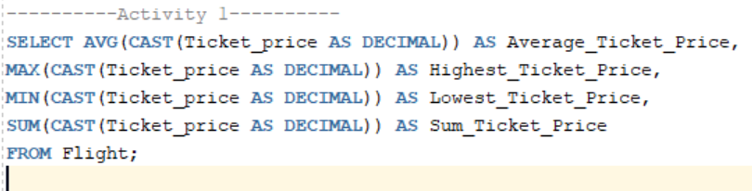

Output:

